Name of group: Spartacists
Symbol: Leaders: Rosa Luxembourg and Karl Liebknecht

Who were they?
The Spartacists was a nickname for the KPD – German Communist Party. They were a political party who wanted Germany to have a communist revolution like Russia.
Why did they try to take over Germany?
The Spartacists believed that Germany should become a communist state. They wanted Germany to be run by councils of workers, not as a democracy. These councils of workers would take over the factories, farms and the government. They wanted to make this happen by using violence – exactly like the Communists had done in Russia.
What date did they try to take over Germany?
January 1919
How were they defeated?
Ebert made an agreement with the German army (Reichswehr) and the Friekorps (groups of WW1 veterans) to help put down the rebellion. Bitter street fighting followed and several hundred people were killed. However, the Spartacists were no match for the army and the Freikorps. Luxembourg and Liebknicht were captured and murdered, their bodies being thrown into a canal. Many German people were shocked by the violence. However, people accepted Ebert’s actions because many Germans were very afraid of communism.
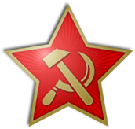
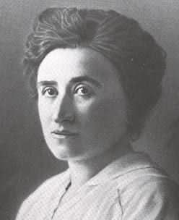
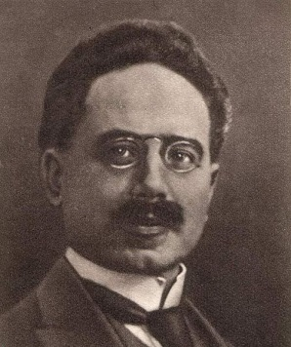

Name of group: Freikorps
Symbol: Leader: Wolfgang Kapp

Who were they?
The Freikorps was a group of ex-soldiers from WW1. They wanted Germany to be run like it was under the old Kaiser. They hated the communists, but they did not like democracy either.
Why did they try to take over Germany?
The Weimar government said in March 1920 that the size of the army would be reduced and that the Freikorps would have to give their weapons back. They refused to comply and instead planned to form a right wing government with the politician Wolfgang Kapp as Chancellor. The German army in Berlin (Reichswehr) supported the putsch (rebellion) and when the German army stationed outside Berlin refused to fire on their comrades, it looked like the putsch would be successful.
What date did they try to take over Germany?
March 1920
How were they defeated?
With the army not helping, Ebert asked the people of Berlin to show their opposition to the Freikorps by going on strike. Berlin’s roads, railways, power, water and sewage services were all brought to a standstill. After a few days, Kapp realised that he could not succeed and left the country.
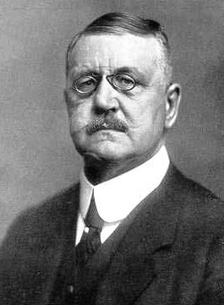
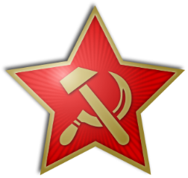

Swastika, later adopted by the Nazi Party.
Iron Cross for bravery awarded during WW1.

Spartacists | Freikorps
Symbol: | Symbol:
Leaders:  - ……………………………………………………………………………  - …………………………………………………………………………… | Leader:  - ……………………………………………………………………………
Who were they?  - ……………………………………………………………………………  ……………………………………………………………………………  - ……………………………………………………………………………  ............................................................................... | Who were they?  - …………………………………………………………………………….  …………………………………………………………………………….  - …………………………………………………………………………….  ................................................................................
Why did they try to take over Germany?  - ……………………………………………………………………………  ……………………………………………………………………………  - ……………………………………………………………………………  ............................................................................... | Why did they try to take over Germany?  - ……………………………………………………………………………  ……………………………………………………………………………  - ……………………………………………………………………………  ...............................................................................
What date did they try to take over Germany?  - …………………………………………………………………………… | What date did they try to take over Germany?  - ……………………………………………………………………………
How were they defeated?  - ……………………………………………………………………………  ……………………………………………………………………………  - ……………………………………………………………………………  ...............................................................................  - ……………………………………………………………………………  ............................................................................ | How were they defeated?  - ……………………………………………………………………………  ……………………………………………………………………………  - ……………………………………………………………………………  ...........................................................................

