Name: _______________________________________________________
LO: To explore aspects of the Buddhist Worship.
Outcomes:
I will be able to identify three features of a Buddhist temple. (L3-4).
I will be able to explain at least two Buddha symbols. (L3-5).
I will be able to create a symbolic message and container. (L4-6).

I want to participate in this lesson; I will stick to the following rules;

- Stop talking; give the teacher your full attention after a countdown.
- Listen to all instructions.
- Participate in the activity and engage with the task.
- LISTEN to the other groups when they present.
- Place my hand up should I need any help (Not get up)
- Be sensible and stick to Buddhism as a topic.

Failure to follow these instructions will result in you leaving the class and working in another room…

SIGNED __________________________

TASK: In groups of 4 you are to create a t-shirt of information about Buddhism.
You will have 30 minutes.
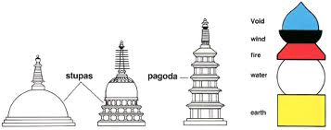
Some of you will be chosen at random to present your information to the rest of the class. You will all evaluate their efforts.
You have these information sheets to help.
BUDDHIST WORSHIP
- Buddhists temples are known by many different names including Stupas and Pagodas.
- Some are believed to contain a relic of the Buddha.
- They may be large or small, sometimes beautifully decorated.
- They are often surrounded by a monastery and are places of pilgrimage.
- Buddhists may walk around them as a sign of respect, gather to chant, meditate or make offerings.
WORSHIP AT A SHRINE
- Buddhists have many different ways of worshipping. One way is at a shrine – this can be in a temple or even in their home.
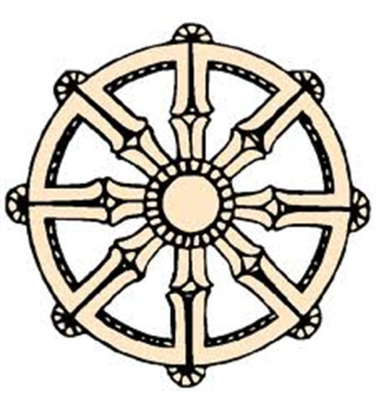
- They could feature the following items; Incense, statues of Buddha, Candles, Lotus Flowers, Offerings of fruit, flowers and water. These are symbolic items that have other meanings.
BUDDHIST SYMBOLS
- To the right is the Buddhist Symbol. It represents the ‘Noble Eightfold Path’. It is sometimes called the middle way and shows Buddhist the path to achieve spiritual enlightenment and cease suffering.
- There are other symbols in Buddhism. For example the position of the hands in images of the Buddha has other meanings. (See your other hand-out).
MUDRAS
- The position of the hands on Buddha images has special meanings – these are called mudras.
- One hundred and eight mudras are used in regular Tantric rituals
MANTRAS
- As part of worship Buddhists chant mantras.
- These are a combination of sounds which do not translate into English.
- They symbolize a particular aspect of enlightenment and are associated with one of the Buddha images.
- For Example – Om Mani Padme Hum. This could mean Generosity, Morals, Patience, Carefulness and Wisdom. A mantra is similar to a motto, think about the schools motto…
YOU NEED TO COME UP WITH YOU OWN FOR THIS TASK.
PRAYER WHEELS
- Buddhists sometimes write a mantra on a piece of paper and place it inside the prayer wheel.
- The turning of the prayer wheel symbolizes that the spiritual power of the mantra is released into the world.
YOU WILL NEED TO COME WITH YOUR OWN MESSAGE FOR A L6.
OTHER USEFUL INFORMATION
Buddhism is a spiritual tradition that focuses on personal spiritual development and the attainment of a deep insight into the true nature of life.

Key facts
- Buddhism is 2,500 years old
- There are currently 376 million followers worldwide
- There are over 150,000 Buddhists in Britain
- Buddhism arose as a result of Siddhartha Gautama's quest for Enlightenment in around the 6th Century BC
- There is no belief in a personal God. It is not centred on the relationship between humanity and God
- Buddhists believe that nothing is fixed or permanent - change is always possible
- The path to Enlightenment is through the practice and development of morality, meditation and wisdom.

Four Noble Truths.
- The truth of suffering (Dukkha)
- The truth of the origin of suffering (Samudāya)
- The truth of the cessation of suffering (Nirodha)
- The truth of the path to the cessation of suffering (Magga)

KEY WORDS
ANAATA – There is no such thing as the self.
ANNICA – Everything changes, nothing lasts for ever.
BUDDHISM – The religion following the Buddha.
CRAVING – Part of the Dukkha
DUKKHA – The four noble truths, the answer to enlightenment.
ENLIGHTENMENT – The goal of all Buddhists.
IMPERMANENCE – Change!
MANTRAS – A Buddhist chant.
MUDRAS – Hand positions for a Buddha.
PAGODA / STUPAS – Type of Buddhist temple
SANGHA – Buddhist
SUFFERING – Part of the Dukkha
SHRINE – A place of worship or peace at a Buddhist home.
SYMBOL – An image or sign with another meaning…

NAME: ___________________________________________ TEACHER ________________________________________
Group | Worship (Take notes, what you have learnt) | Mudras(Take notes, what you have learnt) | Mantras (Take notes, what you have learnt) | LEVEL?
1
2
3
4
5
6
Group | Worship (Take notes, what you have learnt) | Mudras(Take notes, what you have learnt) | Mantras (Take notes, what you have learnt) | LEVEL?
7
8
9
10
11
12

