Fill in the table below by awarding a mark between 1 (good) and 5 (bad) or a comment as needed for each of the siege weapons.
Siege Weapon | How easy to use? | How easy to build? | What sort of damage can they do? | How mobile are they? | Are they quick to build / carry out? | Are they risky for your own army? | What is the main advantage of this siege weapon?  What is the main disadvantage of this siege weapon?
Besieging

Battering Ram

Catapult /Trebuchet

Siege Tower | 3 | 3 | 0 |  |  |  | It allows you to get over the top of the walls without using ladders!
Undermining

Which form of siege weapon do you think is the most effective, and why?
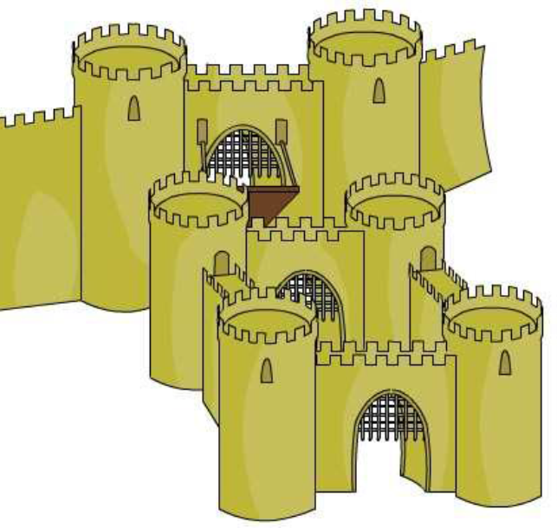
LABEL THE CASTLE WITH AS MANY DEFENCES AS YOU CAN, WHAT ARE THEY, HOW GOOD ARE THEY? What else can you do?

