Year 11, Unit 3B Exam, 1 hr 15 mins
- Study Source A.
What can you learn from Source A about the Jarrow Crusade? (6)
- Study Source B and use your own knowledge.
What was the purpose of this photograph? Use detail of the photograph and your own knowledge to explain your answer. (8)
- Study Source C.
Use Source C and your own knowledge to explain why Jarrow had a lasting effect? (10)
- Study Source D and E and use your own knowledge.
How reliable are Sources D and E as evidence of Jarrow support? Explain your answer, using Sources D and E and your own knowledge. (10)
- Study all of the Sources (A to F) and use your own knowledge.
Spelling Punctuation and grammar will be assessed in this question.
Source F suggests that the Jarrow March had some success.
How far do you agree with this interpretation? Use your own knowledge, sources D, E and F and any other sources you find useful to explain your answer. (16) +4SPAG

Source Pack
Background information
The members of Jarrow Town Council from all political parties marched under the banner of the ‘Jarrow Crusade’ rather than as a hunger march. Jarrow experienced upwards of 70% unemployment. The men were demanding that a steel works be built to bring back jobs to their town, as Palmer's shipyard in Jarrow had been closed down in the previous year. Some Historians believe that the Jarrow march was successful others suggest that it was not.

Source A: From a book about the Jarrow crusade writing in 2005.
Regular donations to march funds showed the level of support for the Crusade. Donations came from pass motorists, from audiences at their daily public meeting, from workplace collections and from the general public. In total the Jarrow Crusade raised £1,567 0s and 5d. Of this, £680 16s 11d cane from the general public. A finance committee was in charge of keeping an account of all that was taken in and spent. In all, there were four committees organising the march: roads and food; finance; publicity; and health.
Source B: An image of the Jarrow marchers in 1936.
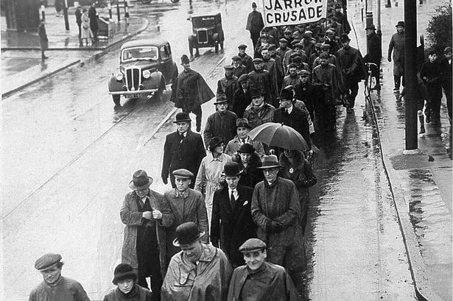
Source C: From a book about the Jarrow Crusade written in 2005.
Struggles of the 1930’s had an effect on rebuilding after the War. There was unemployment provision, a regional policy, the National Health Service and government commitment to full employment.
Source D: Extract from the Guardian paper 1936
“Harrogate welcomed the Jarrow marches to-day as cheerfully as if they were a relief column raising a siege.
The music of the mouth-organ band might have been that of the bagpipes so surely did it bring the people flocking, and when the two hundred reached the Concert Rooms there were hundreds of folk drawn up on the slopes around to cheer them.”
Source E: An extract from an historian in 1950.
“The marchers themselves were generally poorly-received, and were entertained by some sympathisers when they reached London. Despite this, their demonstration at Hyde Park Corner on 1st November was sparsely attended in comparison with an adjacent Communist meeting, which disbanded to swell the Jarrow men's numbers.
The marchers made no en masse assault on the House of Commons, leaving Ellen Wilkinson to present their petition on 4th November, watched by some of her fellow protesters in the gallery. Despite Ellen's eloquence as the petition was accepted, no specific proposal was made for Jarrow's relief. Ellen later told one of her colleagues that, when she had asked the prime minister to receive a deputation from the men, he had refused: 'He said he was too busy.”

Source F: From the BBC in 2016
“In Jarrow, a ship-breaking yard and engineering works were established in 1938 and the Consett Iron Company started a steelworks in 1939. However, in areas such as Jarrow the depression continued until World War Two, when industry prospered as a result of the country's need for rearmament.”

