Lesson Objective – To investigate the reasons why people migrate.
Learning Outcomes.
I will be able to define the key terms related to migration. (Level 3)
I will be able to explain reasons why people migrate. (Level 4/5)
I will be able to analyse the UK immigration policy (Level 5/6)

Fill in the Blanks.
There are three main types of employment; Primary, S__________ and T____________.
Primary Industries involve people collection the Earth’s N_________ resources. Farming and mining are examples.
S___________ Industries employ people to make things. Manufacturing is an example of this.
Tertiary industries provide a S__________. They give help to others. No goods are made in this industry. T________ and N________ are examples of Tertiary jobs.
Generally a More Economic Developed C________ would have more ___________ jobs than Primary jobs. Whereas a Less ____________ developed Country would have more ____________ jobs than ____________ jobs.
EXT: List as many Primary, Secondary and Tertiary jobs that you can.
Today’s Key Words!

Migration – the movement of people to a new area or country.
Internal Migration – Movement of people within a country.
International Migration – Movement of people to a new country.
Push Factors – Factors that make people want to move away from an area.
Pull Factors – Factors that make people want to move to an area.
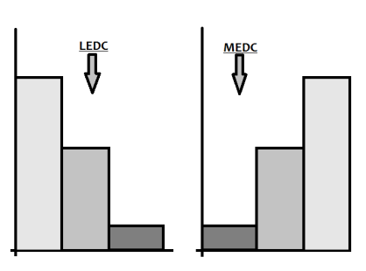 Lesson Objective – To investigate the

Lesson Objective – To investigate the reasons why people migrate.
Learning Outcomes.
I will be able to define the key terms related to migration. (Level 3)
I will be able to explain reasons why people migrate. (Level 4/5)
I will be able to analyse the UK immigration policy. (Level 5/6)

Fill in the Blanks.
There are three main types of employment; Primary, S__________ and T____________.
Primary Industries involve people collection the Earth’s N_________ resources. Farming and mining are examples.
S___________ Industries employ people to make things. Manufacturing is an example of this.
Tertiary industries provide a S__________. They give help to others. No goods are made in this industry. T________ and N________ are examples of Tertiary jobs.
Generally a More Economic Developed C________ would have more ___________ jobs than Primary jobs. Whereas a Less ____________ developed Country would have more ____________ jobs than ____________ jobs.
EXT: List as many Primary, Secondary and Tertiary jobs that you can.
Today’s Key Words!

Migration – the movement of people to a new area or country.
Internal Migration – Movement of people within a country.
International Migration – Movement of people to a new country.
Push Factors – Factors that make people want to move away from an area.
Pull Factors – Factors that make people want to move to an area.

