Match the site factor with its description.

Site factors affecting settlements

|  |  |  |
| --- | --- | --- |
| **Site factor** |  | **Reason required** |
| Water supply |  | These are easy to cross by foot or a bridge. |
| Protection |  | This is needed for drinking, cooking and washing. However too much can be a problem. |
| Building materials |  | This is important to keep warm, south facing areas provide more sun, and trees provide shelter from wind. |
| Shelter |  | Wood and stone was needed for building and could be collected from a forest |
| Flat land |  | This was needed, as it is easier to build on and grow crops. |
| Wood supply |  | This was important to prevent attack. Hilltops are good for seeing into the distance. |
| Rivers |  | This is needed to have fires for warmth and cooking. |

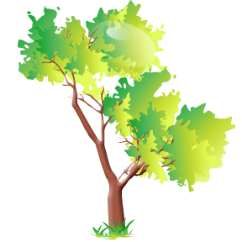

|  |  |  |
| --- | --- | --- |
| **Site factor** |  | **Reason required** |
| Water supply |  | These are easy to cross by foot or a bridge. |
| Protection |  | This is needed for drinking, cooking and washing. However too much can be a problem. |
| Building materials |  | This is important to keep warm, south facing areas provide more sun, and trees provide shelter from wind. |
| Shelter |  | Wood and stone was needed for building and could be collected from a forest |
| Flat land |  | This was needed, as it is easier to build on and grow crops. |
| Wood supply |  | This was important to prevent attack. Hilltops are good for seeing into the distance. |
| Rivers |  | This is needed to have fires for warmth and cooking. |

Match the site factor with its description.



Which site is perfect for a settlement?

# A settlement site is the place where ..............................................

………………………………………………………………………………………………………………………………………………………………….………………………………………………………………..

There are a number of natural advantages of this site. Firstly ………………………………………………………………………………………………………………..

…………………………………………………………………………………………………………………Secondly,………………………………………………………………………………………………………………………………………………………………….……………………………………………………………………………………………………………………………………………………………………

However, there are some natural disadvantages. Firstly…………… …………………………………………………………………………………………………………………

………………………………………………………………………………………………………………………………………………………………….………………………………………………………………………………………………………………………………………………………………….…………………………………………………………………………………………………………………………………….

This site is better than site _______ I think this because……… …………………………………………………………………………………………………………………..

…………………………………………………………………………………………………………………. ……………………………………………….…………………………………………………………………………………………………………………………………………………………………………………….

In conclusion…………………………………………………………………………………………..

…………………………………………………………………………………………………………………………………………………………………………………………………………………………………………………………………………………………………………………………………………………….

Key words

protection wood river flood building materials water drinking crops hills flat land building easily