WALT: What were the causes of the First World War?
WILFS:
L4 – Describe ONE of the causes of WW1
L5 – Explain ONE cause of WW1.
L6 – Compare at least TWO causes of WW1
L7 – Evaluate at least TWO causes of WW1

Key Words for this topic include; Can you define them?

Militarism, alliances, imperialism, nationalism, Kaiser, Britain, France, Russia, Germany, Austria-Hungary, Italy, European Powers, British Empire.

There are multiple causes of the First World War; we will outline them below.

For your exam you will need to give multiple causes of the First World War and decide whether there was ONE cause or MULTIPLE causes of World War One and which best explains it.

M = Militarism. (The idea that there was an arms (guns) race mainly between Britain and Germany. There was also a naval race (Battleships such as the Dreadnaught between Britain and Germany).

In one sentence what is Militarism, why could this make war more likely?

A = Alliance system. (That countries were allied to each other (the promise that they would go to war if the other was invaded) the two most important I

Which countries were in the Triple Alliance, who was in the Triple Entente?
N = Nationalism. (The belief that YOUR country is better than another country, this applies to Serbians who clashed with Austrians, ultimately this led to the Black Hand assassinating Franz Ferdinand.

Where was the Balkans?

I = Imperialism. (Britain, France, Russia, Austria-Hungary and Italy all had Empires (Countries such as India and Canada were part of the British Empire) Britain’s was the largest. Germany in 1901 and the Kaiser demanded an overseas empire that would threaten the British Empire).

Why was Germany a threat to Britain? Could Germany want to expand further?

A = Assassination of Franz Ferdinand. (This is often described as the trigger of the First World War. Everything other point (MANI) were causes of problems between countries but it was the assassination that led to war breaking out in 1914.

Would war have occurred IF Franz Ferdinand hadn’t have been assassinating?

Use the links below to help you revise, understand and answer the questions provided. A likely exam question is “Why did war break in 1914?”

http://www.bbc.co.uk/learningzone/clips/four-main-causes-of-the-first-world-war/5646.html

http://www.bbc.co.uk/bitesize/ks3/history/20th_century/first_world_war/revision/3/

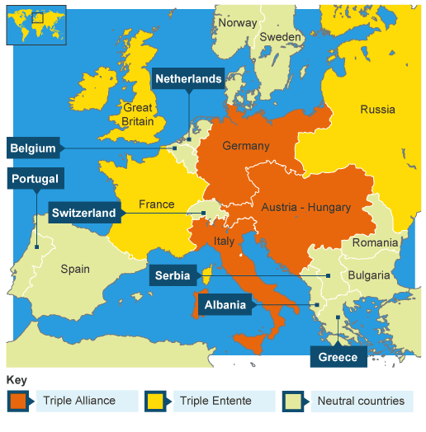

Make sure you know about the problems between the Balkans, Serbs and others – Nationalism?

28 June | The Austrian Archduke Franz Ferdinand was shot by Serb terrorists on a visit to inspect Austrian troops in Bosnia.
5 July | Germany promised total support for Austria
28 July | Austria declared war on Serbia – this angered Russia.
30 July | Russia mobilised her army – this alarmed Germany.
3 August | Germany implemented the Schlieffen Plan and invaded France through Belgium.
4 August | Britain declared war on Germany.

Make sure you know the road to war, when was MANI?
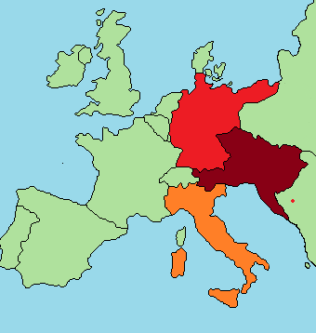

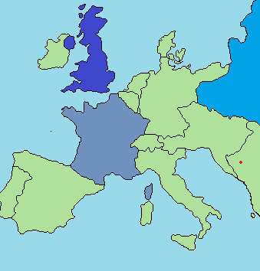

Can you label the two images on the left and right?

