**SOURCE A**

Photograph of the Great Kennington Demonstration 1848.

Afraid that the meeting would result in a riot. The government sent 8,000 soldiers and 150,000 special constables on duty.

Some people said 300,000 turned up. Others said just 10,000.

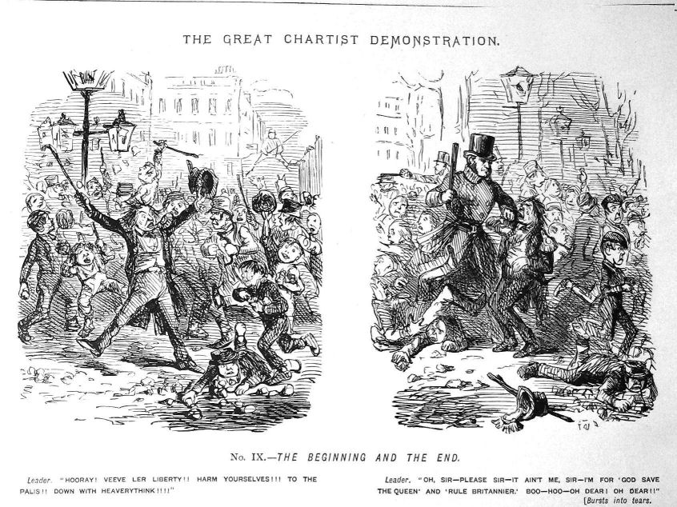

**SOURCE C**

Cartoon from the Time.

On the left is the Cartoonist’s impression of the demonstrations. Is it peaceful, are they listening?

On the right is the Cartoonist’s impression of the police intervention

**SOURCE B**

Copy of a Poster for Chartist demonstration.

