What is a settlement and what kinds of functions can a settlement have?
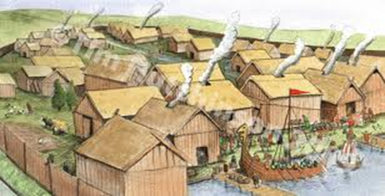
A settlement is a place where people live. For a settlement to grow up it had to have a particular use. This use is known as the settlement function. Different settlements have different functions, including industrial towns, holiday resorts, ports and market towns.
Activity
- Complete the following definitions by linking (with a straight line).
Where goods are manufactured in industrial towns.
Settlement
Function
Goods that are brought into the country.
Holiday
2. What do you think is the function of Newham as a settlement?
Goods that are sent overseas.
Market Town
The reason why a town was first built.
A place where people go on holiday.
Industrial town
A place where people make things.
Factories
A place where people buy and sell things.
Port
Imports
A place where goods are brought in and out of a country.
Exports
Something people do in their leisure time.
A place where people live.
Resort

